(Note: This template has been created as a guide for use with Full Board submissions; however, it can be used as a framework and updated, as applicable, for Expedited submissions.)

Protocol Title

Principal Investigator’s name and address
Some place the Sub-Investigators and their affiliations here:
John/Jane Doe, Ph.D., Associate Professor
Department
School/University
Support Provided by:
(Funding source if any)
IND/IDE#:
(Delete if N/A)

Table of Contents:
Study Schema
- Background & Rationale
- Objective(s)
  - Primary Objective
  - Secondary Objective
  - Tertiary/Exploratory/Correlative Objectives
- Outcome Measures
  - Primary Outcome Measures
  - Secondary Outcome Measures
  - Tertiary/ Exploratory/ Correlative Outcome Measures
- Eligibility Criteria
  - Inclusion Criteria
  - Exclusion Criteria
- Study Design
- Enrollment/Randomization
- Study Procedures
- Study Calendar
- Reportable Events
- Data Safety Monitoring
- Study Withdrawal/Discontinuation
- Statistical Considerations
- Data Management
- Privacy/Confidentiality Issues
- Follow-up and Record Retention
- References

Appendix
Abbreviations
This page is optional. The list below includes some common abbreviations. However, this list should be customized for each protocol (i.e., abbreviations not used should be removed and new abbreviations used should be added to this list).
AE | Adverse Event
CFR | Code of Federal Regulations
CLIA | Clinical Laboratory Improvement Amendments
CMP | Clinical Monitoring Plan
COC | Certificate of Confidentiality
CRF | Case Report Form
DCC | Data Coordinating Center
DHHS | Department of Health and Human Services
DSMB | Data Safety Monitoring Board
DRE | Disease-Related Event
eCRF | Electronic Case Report Forms
FDA | Food and Drug Administration
FDAAA | Food and Drug Administration Amendments Act of 2007
GCP | Good Clinical Practice
GLP | Good Laboratory Practices
GMP | Good Manufacturing Practices
GWAS | Genome-Wide Association Studies
HIPAA | Health Insurance Portability and Accountability Act
IB | Investigator’s Brochure
ICH | International Conference on Harmonisation
ICMJE | International Committee of Medical Journal Editors
IDE | Investigational Device Exemption
IND | Investigational New Drug Application
IRB | Institutional Review Board
ISM | Independent Safety Monitor
ISO | International Organization for Standardization
MedDRA | Medical Dictionary for Regulatory Activities
MOP | Manual of Procedures
NCT | National Clinical Trial
NIH | National Institutes of Health
OHRP | Office for Human Research Protections
PI | Principal Investigator
QA | Quality Assurance
QC | Quality Control
SAE | Serious Adverse Event
SAP | Statistical Analysis Plan
SMC | Safety Monitoring Committee
SOA | Schedule of Activities
SOP | Standard Operating Procedure
UP | Unanticipated Problem
US | United States

Background & Rationale
Provide the history of the problem/disease, justification for conducting the study, and results of similar studies or pilot data. Provide scientific background and basis for hypothesis to be tested. Discuss how this affects the target population and how many are affected.
Describe the investigational product, if applicable.

Objective(s)
  - Primary Objective
  - Secondary Objective
  - Tertiary/Exploratory/Correlative Objectives
The purpose/why of the study. Provide clearly stated objectives that have well-defined endpoints (to be defined in Section 3.0 below).

Outcome Measures/Endpoints
  - Primary Outcome Measures
  - Secondary Outcome Measures
  - Tertiary/Exploratory/Correlative Outcome Measures
Indicate what will be measured and how it will be measured (not why it will be measured). Be as specific as possible: include all time points at which outcome measures are assessed.

Eligibility Criteria
  - Inclusion Criteria
List the criteria:
- Bullet or number each criteria for easy identification.
  - Exclusion Criteria
List the criteria:
- Bullet or number each criteria for easy identification.
If there are different inclusion/exclusion criteria for different arms/groups of subjects, they should be identified/grouped separately.

Study Design
Briefly describe the study design and indicate, in general terms, how the design will fulfill the intent of the study.
This section should include a diagram that provides a quick “snapshot” of the study and ideally be limited to 1 page. Below are examples of schematics that show the level of detail needed to convey an overview of the study design. Depending on the nature of your study, one example may be more appropriate than another. Regardless, the examples included here are intended to guide the development of a schematic that is appropriate to the planned study design and will need to be customized for the protocol. Revise with study-specific information and adapt the diagram to illustrate your study design (e.g., changing method of assignment to study group, adding study arms, visits, etc.).
Example #1: Flow diagram for randomized, controlled trial
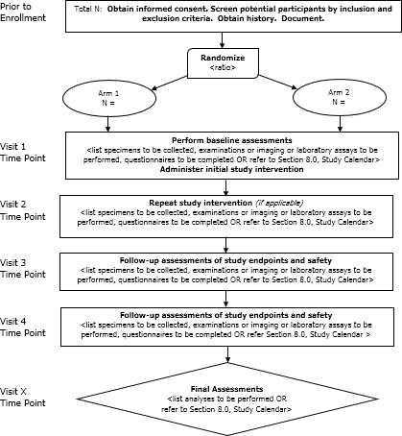
Example #2: Timeline Diagram for randomized, controlled trial
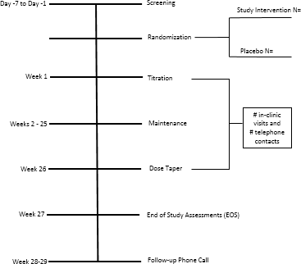
Example #3: Social Behavioral Research using snowball sampling
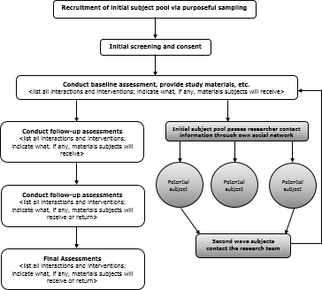

Enrollment/Randomization
Provide the plan for identification and enrollment of participants. Explain the process for randomization and blinding, if applicable.

Study Procedures
Describe each procedure separately. Include all interventions, experimental manipulations, data collection procedures, and measurements. Clearly explain whether procedures are being conducted as part of clinical care or for purposes of the research (or alternatively, list study procedures being conducted for research purposes only). If data is collected from standard of care procedures (i.e., chart review), this should also be described.
Provide a description of what the participants will experience. For example, provide a description of the instructions that will be given to the participants, activities in which they will engage, the length and timing of involvement, and the circumstances under which they will provide data (e.g., phone calls, spending time in an uncomfortable position, group assessments, one-on-one interview, videotaping, audio taping, etc.). Provide a description of study drug doses, route of administration, and schedule.

Study Calendar
Provide a detailed description of each study visit (e.g., screening, visit 1, visit 2, how unscheduled visits will be handled, etc.). List the days, time frame, and duration of the study. Begin with screening procedures if applicable. Provide a table format to outline what will happen and when it will occur.
Example table:
 | Screening | Visits/Treatment |  |  | Follow-up
 | Day X | Day X | Day X | Day X | Day X
STUDY PROCEDURES
Blood Chemistries
Urine pregnancy
CT chest, abdomen, pelvis
Be aware of criteria prone to deviations. Consider including ranges and time windows in which to draw blood, see the physician/nurse, receive drug, acceptable lab value ranges, etc. For example, “Variations of +/- 7 days from the scheduled visit are permitted.”

Reportable Events
List the process for the reporting of adverse events or unanticipated problems involving risk to participants or others. Indicate where and how to submit AEs/unanticipated problems and the time frame in which to submit. List the regulatory authorities and their contact information for reporting, if needed. Refer to the IU HRPP Reportable Events Policy and Guidance, as needed.
Define what constitutes an adverse event (AE) and serious adverse event (SAE) for this study. Identify when the collection of AEs and SAEs will begin (e.g., at the time of consent vs. at the start of interventions).

Data Safety Monitoring
For minimal risk studies, describe the provisions for monitoring the data to ensure the safety of subjects.
For greater than minimal risk studies, explain who will be responsible for the data and safety monitoring, including their role in the study, if any, and whether the individual or committee is independent from the sponsor and/or PI. Confirm that the following will be monitored as part of the Data Safety Monitoring Plan (DSMP): data quality, subject recruitment, accrual, retention, outcome and adverse event data, assessment of scientific reports or therapeutic development, results of related studies that may impact subject safety, and procedures designed to protect the privacy of subjects. Describe how often individuals or committee responsible for the DSMP will monitor the study. Describe any planned statistical analyses and any pre-planned stopping rules, actions to be taken upon specific events, and/or endpoints.

Study Withdrawal/Discontinuation
List the process for the participant to withdraw himself or herself from the study. List the process for being withdrawn from the study and the indications for withdrawal.

Statistical Considerations
State what the sample size of the study is and describe how the sample size of the study was determined. The sample size justification must be based on the goals of the study. If the goal is to test a hypothesis, a power calculation should be provided that includes the statistical test the power calculation is based on, the effect size of clinical interest, the significance level (Type I error), and power. Describe the planned methods for statistical analysis for each outcome measure in the study. Describe any possible deviations and their statistical impact. State the significance level to be used for statistical tests. If applicable, include a description of interim analyses and early stopping rules. Describe how missing data will be handled in the analyses.
For assistance with Statistical Considerations, working with a statistician is recommended. If the investigator has worked with an IU biostatistician in the past, contact them. If the investigator has no previous experience working with biostatistics, contact the following:
Indianapolis campus: George Eckert (geckert@iu.edu)
Bloomington campus: Stephanie Dickinson (sd3@indiana.edu) or Michael Frisby (mfrisby@indiana.edu)

Statistical Data Management
How the data will be collected, managed, and stored needs to be described in this section. Template language is provided below:
Primary data will be collected via [e.g., paper, phone interviews, direct data capture from measurement instrument] and stored electronically in [e.g., REDCap, OnCore, SPSS files on Department Server]. The storage location will be backed up [automatically, manually] every [day, week, month]. Other data sources include [e.g., outside lab data, data from INPC] that will be stored in separate electronic files and merged with the primary data as needed. Quality assurance steps will include: [e.g., 1) built in range checks; 2) testing of database by study team prior to moving to production mode]. The following quality control methods will be used: [e.g., 1) [double entry of data, single entry with random checks of accuracy]; and 2) extraction and cleaning of data that will be used for analysis every [6 months, 1 year].

Privacy/Confidentiality Issues
Discuss the methods for ensuring participant privacy and the methods for protecting privacy and confidentiality. Explain how data will be stored and accessed.

Follow-up and Record Retention
List the duration of the study. List the duration of record retention and the method for destruction or the possibility of indefinite archiving of information.

References
Include a list of relevant literature and citations for all publications referenced in the text of the protocol.

Appendix
Provide additional relevant materials, such as questionnaires, drug interactions, etc.

