EConfirm (ECC)
Confirmer
Guide
November 2021

Table of Contents
Overview 3
Accessing EConfirm 3
EConfirm Project Workflow 3
The Confirmation Process 4
Your Work List 5
Statements Awaiting Confirmation 5
The Project Statement Page 5
Work List Summary Pane 5
Statement Information Pane 6
Project Statement Pane 6
Confirming a Project Statement 7
Four Clicks to Confirmation 7
Partially Confirm the Project Statement 9
Partially Confirm and Request Revision 11
Request Revise Payroll 13
Project Workflow Statuses 14

Overview
EConfirm, or ECC, is the system used to confirm effort for all Indiana University employees with Institutional Base Salary (IBS)* charged to a Federal or Federal Pass-Through sponsored award. This includes salary directly charged or cost shared to the award or with unallowable salary over salary cap tracked on the award.
*Please note: Indiana University (IU) Institutional Base Salary (IBS) is defined as the base salary paid by IU for an individual's appointment, whether that individual's time is spent on research, instruction, administration, or other activities. This includes, if appropriate, salary from both IU and approved practice plan (IUHP) salary. The IUHP portion on IBS must match the percentage of IU IBS presented on project statements in EConfirm.
EConfirm is an ADA-compliant application. It works best using the Google Chrome or Mozilla Firefox browsers.
Indiana University performs an annual confirmation of Institutional Base Salary (IBS) on all federal and federal pass-through sponsored awards for the calendar year. A review period is available during January and February, then a confirmation period during March. Confirmation is on a project basis, with a single project defined as all the IBS activity related to the same KC Award Family. This may include activity on multiple accounts.
Please note that
As an Award Principal Investigator, (Confirmer) you are responsible for reviewing and confirming project statements on an annual basis. Your Department will have one or more Effort Coordinators, Fiscal Officers or financial delegates, who can review your statements and must make any requested revisions within the KFS financial system. One of these Effort Coordinators will be designated as ‘primary’ and will serve as your primary contact for project statement confirmation.

Accessing EConfirm
There are multiple ways to access the EConfirm system:
- A hyperlink from the system-generated email sent to the Confirmer and Primary Effort Coordinator when the effort confirmation statements are ready to be confirmed
- From the EConfirm Task tile at One.iu.edu.
- This direct URL: https://indiana.huronecc.com/ecc/
Note: You will be prompted to sign in with your Indiana University CAS credentials, including DUO two-factor authentication, if you are not already signed in. If you are already signed in, you will be automatically routed to your Work List in EConfirm or directly to the project statement you clicked in the system-generated email.

EConfirm Project Workflow
The standard workflow for federal and federal pass-through project statements is provided below. The project statements move from one status to another depending on the actions taken on the project statement. You can view the list of statuses at the end of this document.
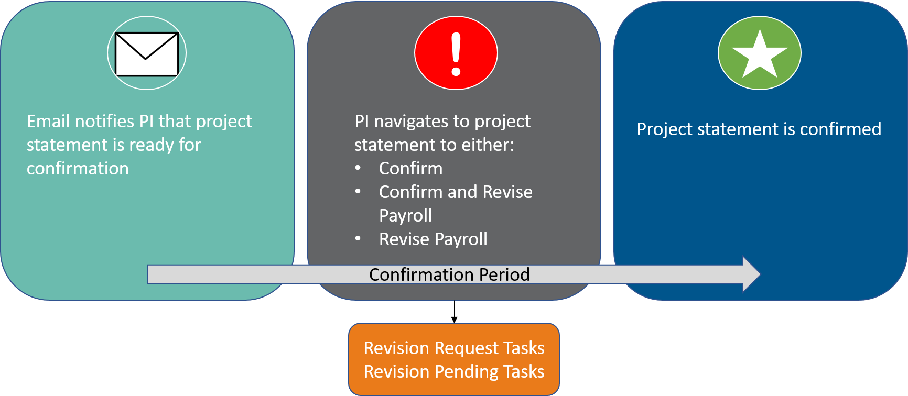

The Confirmation Process
The confirmation process only applies to Federal and Federal Pass-Through sponsored projects. All other non-federally sponsored awards will generate project statements, but those statements will automatically be approved and change to an auto-approved status in EConfirm at the beginning of the confirmation period. These auto-approved statements will not appear on your Work List during that period.
When the confirmation period begins, the confirmer PI will receive a system-generated email notifying them that their project statements are ready for confirmation. The departments Primary Effort Coordinator will be copied on each email.
You will click the project name hyperlink to navigate to the project statement in EConfirm.
This is an example of a notification email:

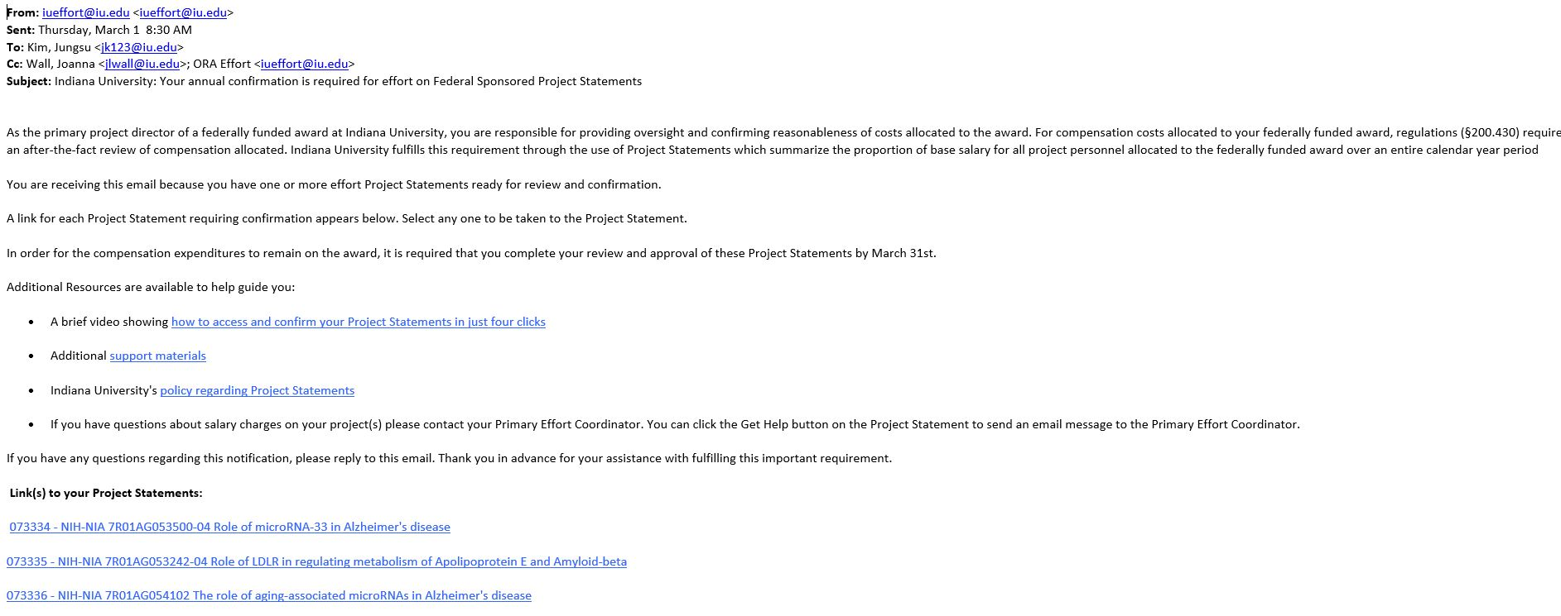

Your Work List
If accessing EConfirm through the direct URL or the task tile in One.IU, you will be taken to the EConfirm home page and be presented with your Work List. This page lists project statements that require your confirmation.

Statements Awaiting Confirmation
The Statements Awaiting Confirmation tab on your home page displays all project statements you are responsible for confirming. During the confirmation period, this tab will show statements that are in Ready for Confirmation status.

The Project Statement Page
If you access EConfirm by clicking a project statement link in the system-generated email you received, you will be taken directly to that project statement in EConfirm.
The Project Statement Page consists of three panes which provide information relevant to the confirmation process:
- Work List Summary Pane
- Statement Information Pane
- Project Statement Pane
At the bottom of the project statement, the following sections appear:
- Notes
- Attachments
- Transactions
- Activity Log
- Email Log
Note: A star icon indicates that there is content available to view in that section. Click the arrow ► to expand and view.

Work List Summary Pane
The top left pane on the project statement displays your Work List. The project statements will be grouped by status .
The arrow icon ► next to your name will be expanded and show all of your project statements in Ready for Confirmation status. You may see additional arrow icons ► that are not expanded for statements in other statuses. Click the arrow icon ► next to a status to view all of your project statements in that status.
A blue star next to the status name indicates that there are project statements in that status.
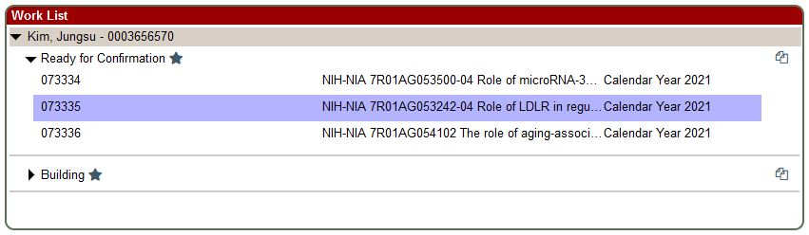

Statement Information Pane
The top right pane displays information about the project for the statement that is highlighted.
This includes a list of account numbers, the lead Department (Chart-Organization Code), dates, title and other identifying information associated with the award represented by this project statement.

Project Statement Pane
The project statement lists all employees who were directly charged, or cost-shared or had salary over the salary cap tracked on that particular project during the calendar year listed.
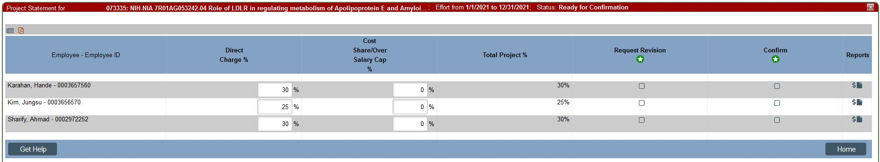

Confirming a Project Statement
During the confirmation process, you should review all project information, payroll and cost share/over salary cap percentages for each employee on the project statement.
As a Principal Investigator, you will have four options when processing a statement:
- Confirm (Four Clicks to Confirmation)
- Partially confirm
- Partially Confirm and Request Revision
- Request Payroll Revision

Four Clicks to Confirmation
Follow these steps if you can confirm the payroll and cost share/over salary cap shown on the project statement is reasonably allocated for employees who worked on the award during the Calendar Year. After navigating to the Project Statement from an email link or from your worklist (your first click) it only takes a few additional clicks to complete confirmation.
- To confirm a statement:
  - Click the Confirm icon to select all lines in the Confirm column. You can also select each checkbox individually.
  - Click the Confirm button in the shaded ribbon at the bottom of the employee list.
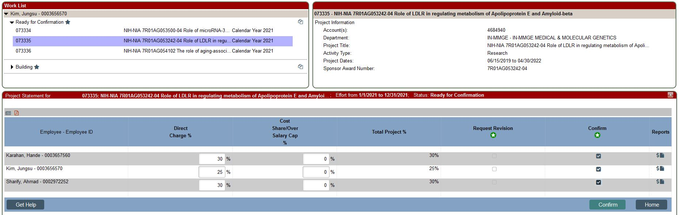
  - Review the Attestation Statement which will list all the employees that you are confirming and click I agree to complete the confirmation process.
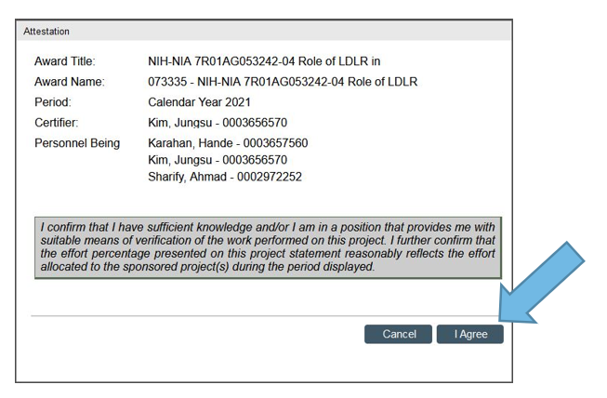
Note: Once an individual is confirmed they cannot be unconfirmed during the regular confirmation process

After clicking I agree, the statement is now in Confirmed status and will be automatically removed from your Work List.

Partially Confirm the Project Statement
Follow these steps if you want to confirm some but not all employees for the Calendar Year.
- To partially confirm a project statement:
  - On the row for each employee whose payroll you wish to confirm, select the checkbox in the Confirm column. Do not select checkboxes for employees with payroll you are not yet ready to confirm.
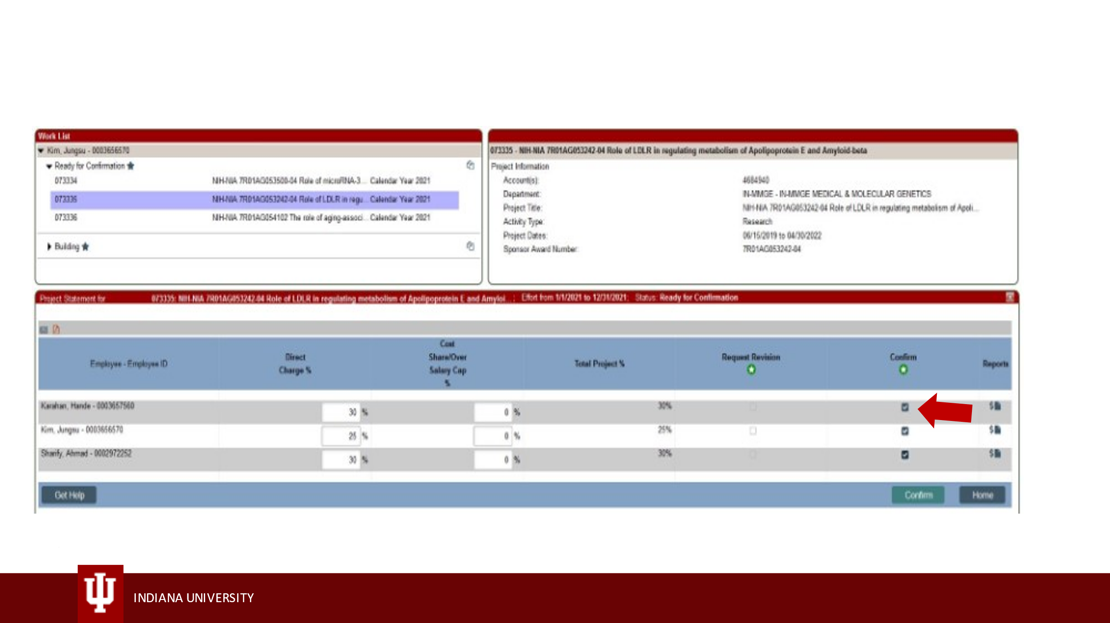
  - Click the Confirm button in the shaded ribbon at the bottom of the employee list.
  - Review the attestation statement and click I agree to confirm only those employees for whom payroll was reasonably allocated. The attestation statement will include employees you are confirming
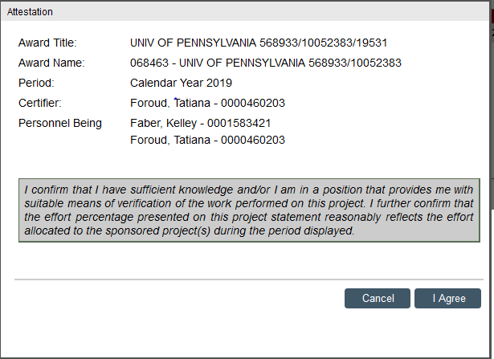
Important Reminder: The statement remains in the Ready for Confirmation status until all employees have been confirmed. After you confirm these employees this confirmation cannot be changed.

Best Practice for Changing Project Statement Effort
If upon review of the project statement prior to confirmation potential changes to the statement are identified, Confirmers should take the following steps:
- Contact the Effort Coordinator to review the project statement
- If after consultation with the Effort Coordinator, there is a change required, the Effort Coordinator will complete the salary transfer (ST) to change the labor charges associated with the project statement revision.
- Once all salary transfers are complete and posted to the IU labor ledger, percentage effort change will also be reflected in EConfirm.
- Please note that effort changes to project statements require salary cost transfers external to EConfirm (ECC). Transfers of expenditures to federal cost reimbursable awards where the cost transfer document is initiated more than three months after the month in which the cost was incurred will be a Late Cost Transfer. Cost transfers affecting a project statement in the confirmation period must be fully routed and approved by March 20th. See the policy, Cost Transfers on Cost Reimbursable Grants and Contracts for additional information
- Information regarding project statement confirmation and requesting effort revisions in EConfirm (ECC) is provided in the following video:
View the IU ECC Confirming a Project Statement video

Partially Confirm and Request Revision

Best Practice for Partial Confirmation
If upon review of the project statement you can confirm that the payroll and cost share/over salary cap shown on the project statement is reasonably allocated for some employees, but identify potential effort revisions for others, contact the Effort Coordinator to review the project statement prior to requesting revisions to individual employee effort.
If after consultation with the Effort Coordinator, there is a change required, the Effort Coordinator will complete the salary transfer (ST) to change the labor charges associated with the project statement revision.

Project Statement Partial Confirmation in EConfirm
If the partial confirmation and project statement revision is initiated in EConfirm, the steps below outline this process.
- To confirm and request a payroll revision:
  - On the row for each employee whose payroll is reasonably allocated, select the checkbox in the Confirm column.
  - Select the checkbox in the Request Revision column for each employee for whom a payroll revision is being requested. This makes the Direct Charge % and Cost Share/Over Salary Cap % columns editable.
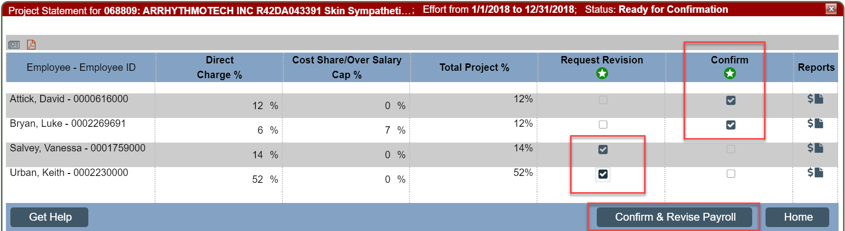
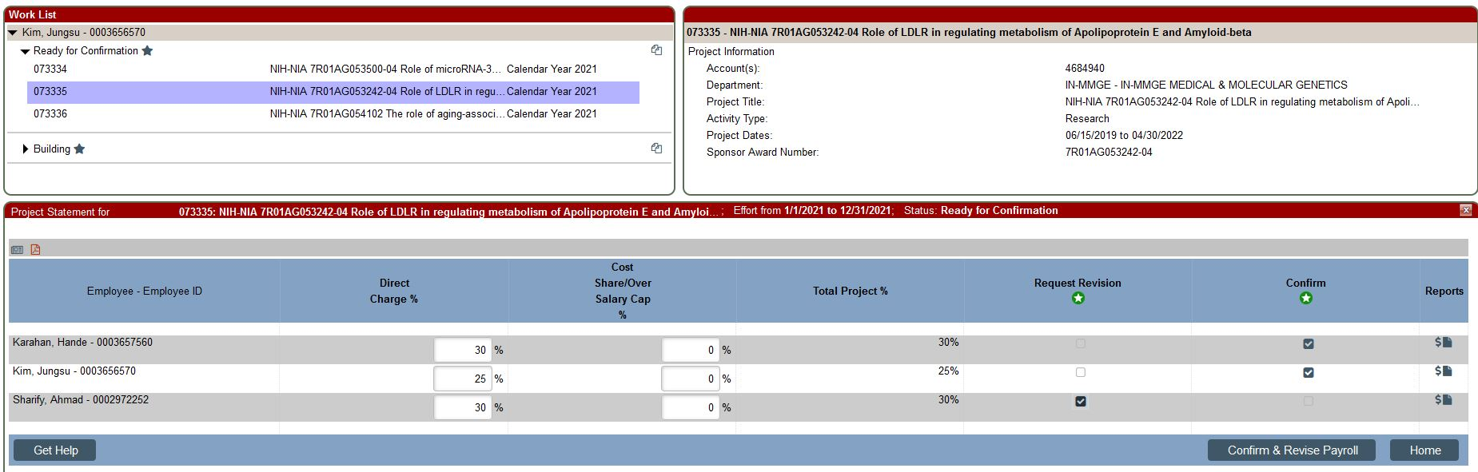
  - Enter the requested revised percentage as a whole number in the Direct Charge % and/or Cost Share/Over Salary Cap % fields.
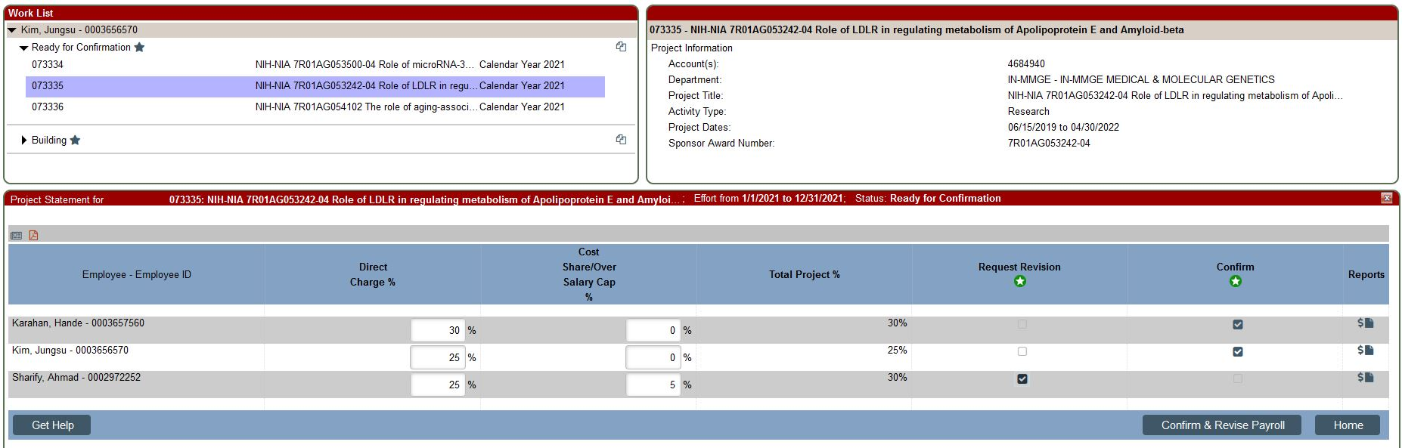
  - Click Confirm & Revise Payroll button in the shaded ribbon at the bottom of the employee list.
Note: If you selected an incorrect Request Revision checkbox, you can uncheck it prior to clicking the Confirm & Revise Payroll button. The percentages will revert to their original amounts. Remember, once an individual is confirmed they cannot be unconfirmed.
The statement will now be in the Revision Requested status. It will no longer be displayed on your Work List and cannot be changed until the Effort Coordinator takes action and sends it back to you. No further action is required by you at this time. A Revision Requested task will be created for the Effort Coordinator to review. After the Effort Coordinator reviews and takes action, you will be required to confirm the payroll not previously confirmed.

Request Revise Payroll

Best Practice for Revision Requests
If upon review of the project statement effort revisions are identified for all employees on the project statement, contact the Effort Coordinator to review the project statement prior to requesting revisions to employee effort.
If after consultation with the Effort Coordinator, there are changes required, the Effort Coordinator will complete the salary transfer (ST) to change the labor charges associated with the project statement revision.

Project Statement Request Revise Payroll in EConfirm
If revision request is initiated in EConfirm, the steps below outline this process.
Follow these steps if you wish to request a payroll revision for all employees on a project statement for the Calendar Year. Please contact your Effort Coordinator if you think an allocation on the statement needs adjustment. You should always confirm any employees on the statement that are reasonably allocated prior to requesting revisions. Once you and your Effort Coordinator agree a revision is needed for all individuals on the statement, follow the steps below.
- To request a revision for all employees in a project statement:
  - Click the Select All icon under Request Revision to select all employees on the project statement. This makes the Direct Charge % and Cost Share/Over Salary Cap % columns editable.
  - Enter the revised percentage as a whole number in the Direct Charge % and/or Cost Share/Over Salary Cap % fields.
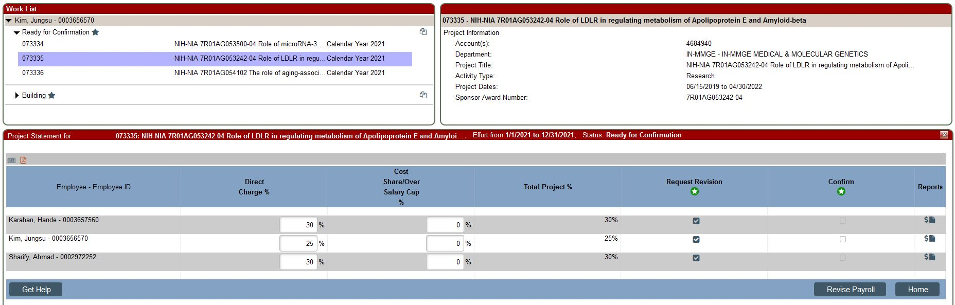
  - Click Revise Payroll in the shaded ribbon at the bottom of the employee list.
The statement will now be in the Revision Requested status. The statement will no longer appear on your Work List and cannot be changed until the project statement is revised and sent back to you. No further action is required by you at this time. A Revision Requested task is created for the Effort Coordinator to review. After the Effort Coordinator reviews and takes action you will be required to confirm the payroll not previously confirmed.

Project Workflow Statuses
The following is a list of the workflow statuses you may see when working with project statements.
Status | Icon | Description
Building |  | This status indicates that a project statement is not yet ready for confirmation. This occurs during the Calendar Year, when payroll and profile data are being loaded and the project statements are building.
Auto Approved |  | This status is for non-federal project statements that are auto approved. The system automatically moves project statements that have no federally sponsored payroll or cost share associated with them into this status when the confirmation period begins.
Ready for Confirmation |  | This status indicates that the Project Statement is ready to be confirmed. Statements move to this status when the Confirmation Period begins, and the statement requires an individual to confirm the payroll charges for the period.
Revision Requested |  | During the Confirmation Period, after a PI clicks the Request Revise checkbox and optionally inputs a corrected payroll and/or cost share percentage, they click the Revise Payroll button which updates the statement status to this.
Revision Pending |  | When new payroll loads to statement in the Revision Requested status and creates a payroll task that will be processed by your Effort Coordinator.
Confirmed |  | This status indicates that every individual on this Project Statement has been confirmed.
Confirmed, Payroll Pending |  | This status indicates that an individual confirmed their Project Statement and a payroll transaction occurred after the fact.  The payroll transaction creates a PAR task and the project statement remains in this status until a system administrator completes the PAR task.
Manually Confirmed |  | This status is when a project statement has been marked as Manual Confirmation. This is an exceptional status that can only be set by system administrators.
Manually Confirmed, Payroll Pending |  | This status is when a project statement has been marked as Manual Confirmation and an additional payroll transaction has been loaded to this project statement, which needs to be reviewed and posted to the statement.
No Confirmation Required |  | This status is when a project statement has been marked as No Confirmation Required. This is an exceptional status that can only be set by system administrators.
No Confirmation Required, Payroll Pending |  | This status is when a project statement has been marked as No Certification Required and an additional payroll transaction has been loaded to this project statement, which needs to be reviewed and posted to the statement.
Re-Opened, Not Confirmed |  | This is the status of a project statement that has been re- opened, and the statement needs to be re-confirmed by the PI.
Reopened by Payroll Adjustment, Needs Confirmation |  | This is the status of a project statement where a payroll transaction was applied, and the statement needs to be re- confirmed by the PI due to changes in the payroll percentages on the project statement.

© 2020 Huron Consulting Group Inc. and affiliates. All rights reserved. Use and distribution without a current software license from Huron are prohibited.
All trademarks, registered trademarks, service marks, and trade names are the property of their respective owners.
Information in this document is subject to change without notice. Published by Huron Consulting Group Inc.
9170 NE Turing Court
Suite 100
Hillsboro, OR 97006

